Construction and Electrocatalytic H₂O₂ Sensing Performance of Nanostructures Derived From Molybdenum-based Compounds

Bo Li

College of Science, Heihe University (Heihe)
libo@hhxy.edu.cn

Molybdenum carbide-based nanocomposites have become a focal point in materials science due to their unique properties, which closely resemble those of noble metals like platinum (Pt). These materials exhibit a similar electronic structure and high stability, making them highly attractive for a wide range of applications, including lithium-sulfur batteries, catalysis, nitrogen reduction, sensors, and water electrolysis. In this study, researchers synthesized and characterized a precursor material, POM@MOF, using X-ray diffraction (XRD) and scanning electron microscopy (SEM) techniques. Building on this, they designed and synthesized a novel molybdenum carbide-based nanocomposite, Cu-Mo₂C/MoC, as depicted in Fig. 1.
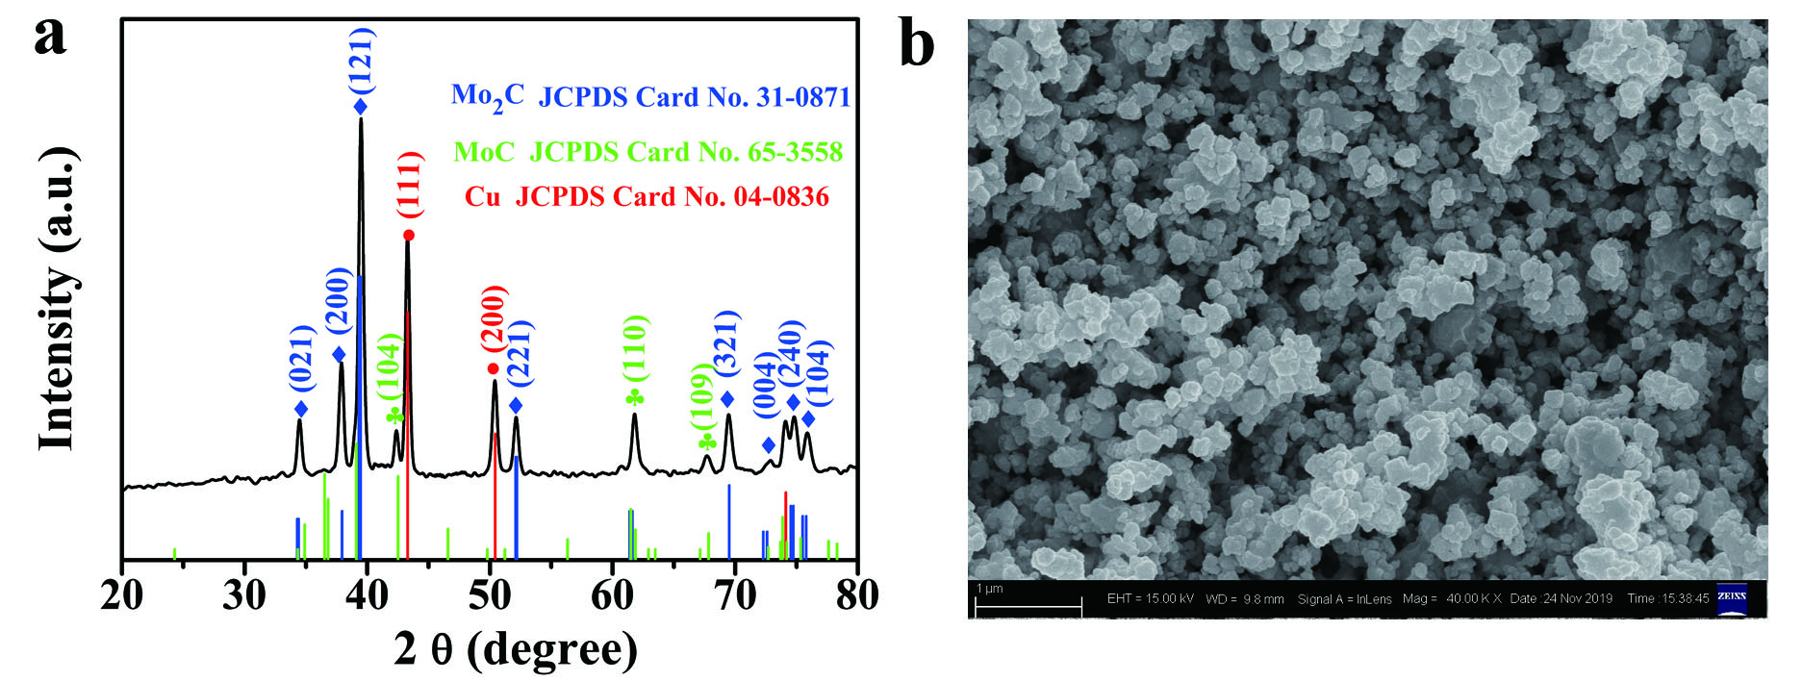
Fig. 1. PXRD pattern (a); SEM image (b) of the Cu-Mo₂C/MoC sample.

This nanocomposite was then fabricated into an electrochemical sensor, Cu-Mo₂C/MoC/GCE, which demonstrated remarkable performance in detecting hydrogen peroxide (H₂O₂). The sensor exhibited a broad detection range of 0,0018 mM to 0,892 mM and an ultra-low detection limit of 0,6 μM, as illustrated in Fig. 2. [1 – 4].
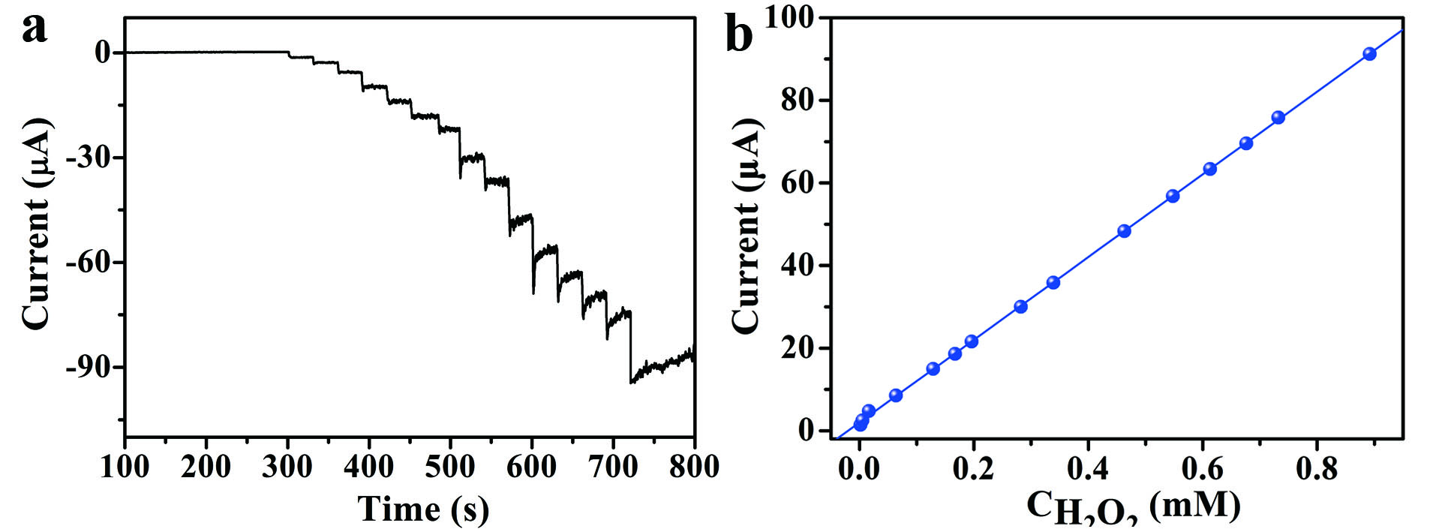
Fig. 2. (a) The i-t curve of Cu-Mo₂C/MoC/GCE with successive injection of different concentrations of H₂O₂ into 0,05 mol·L⁻¹ PBS (pH 7,4), applied potential: -0,4 V; (b) Corresponding calibration plots of the
Cu-Mo₂C/MoC/GCE.
The synthesis of Cu-Mo₂C/MoC involved a carbothermal reduction process of the POM@MOF precursor under controlled conditions, followed by copper doping to enhance its electrochemical properties. The resulting nanocomposite was characterized by XRD, confirming its crystalline structure, and SEM, which revealed its nanoscale morphology (Fig. 1, a, b). When applied as an electrochemical sensor, the Cu-Mo₂C/MoC/GCE displayed excellent sensitivity and stability, as evidenced by the amperometric response (i-t curve) to varying concentrations of H₂O₂ (Fig. 2, a). The corresponding calibration curve (Fig. 2, b) further validated the sensor’s linear response, indicating its reliability for quantitative analysis.
The enhanced performance of Cu-Mo₂C/MoC can be attributed to several factors. First, the synergistic interaction between Mo₂C and MoC phases improves charge transfer kinetics, while copper doping introduces additional active sites, boosting catalytic activity. Second, the nanocomposite’s high stability ensures long-term functionality, making it resistant to common electrode degradation mechanisms. These characteristics position Cu-Mo₂C/MoC as a cost-effective alternative to conventional Pt-based sensors, which are often limited by their high expense and susceptibility to poisoning.
Recent studies have reinforced the potential of molybdenum carbide-based materials in various electrochemical applications. For example, Mao et al. (2024) demonstrated the catalytic efficiency of Mo₂C/MWCNT composites in methanol oxidation reactions, while Han et al. (2024) highlighted their role in improving polysulfide conversion kinetics in lithium-sulfur batteries. Similarly, Upadhyay and Pandey (2022) explored Mo₂C/MoC/C nanocomposites for hydrogen evolution reactions, and Wang et al. (2021) investigated tungsten-doped Mo₂C-MoC heterostructures for enhanced hydrogen evolution in alkaline solutions. These findings collectively underscore the versatility and effectiveness of molybdenum carbide-based materials in advancing electrochemical technologies.
In conclusion, the development of Cu-Mo₂C/MoC nanocomposites represents a significant step forward in electrochemical sensing, particularly for H₂O₂ detection. The material’s outstanding sensitivity, stability, and cost efficiency make it a promising candidate for future applications in environmental monitoring, biomedical diagnostics, and industrial processes. Further research could explore optimization strategies, such as varying dopant concentrations or integrating these nanocomposites into flexible and wearable sensors, to expand their utility in next-generation electrochemical devices.

R E F Е R E N C E

1.Mao, L.X., Fu, L., Zhang, X.Y., Yan, Z.F., Gao, Z.H.,Liu, L., Huang, W., Zuo. Z.J. Effect of transition metals (Ni and Co) in the methanol oxidation reaction electrocatalytic activity on Mo₂C/MWCNT // Molecular Catalysis. – 2024. – V. 567. – P.114455.
2. Han, K.Y., Fuo, D.H., Li, M.M., Deng, S.J., Sun, G.B., Huang, X.Q., Li, H.F. Mixed valence Mo₂C-MoC/C catalyst enhances polysulfides conversion kinetics in lithium-sulfur batteries // Applied Surface Science. – 2024. – V. 663. – P.160138.
3. Upadhyay, S., Pandey, O.P. Synthesis of Mo₂C/MoC/C nanocomposite for hydrogen evolution reaction // Journal of Solid State Electrochemistry. – 2022. – V. 26. – P.559-564.
4. Wang, Q.T., Mi, F.F., Li, J., Wu, Y.X., Zhou, X.Z., Ma, G.F. Ren, S.F. Tunfsten doping generated Mo₂C-MoC heterostructure to improve HER performance in alkaline solution // Electrochimica Acta. – 2021. – V. 370. – P.137796.

